**English language I**

**– Homework V –**

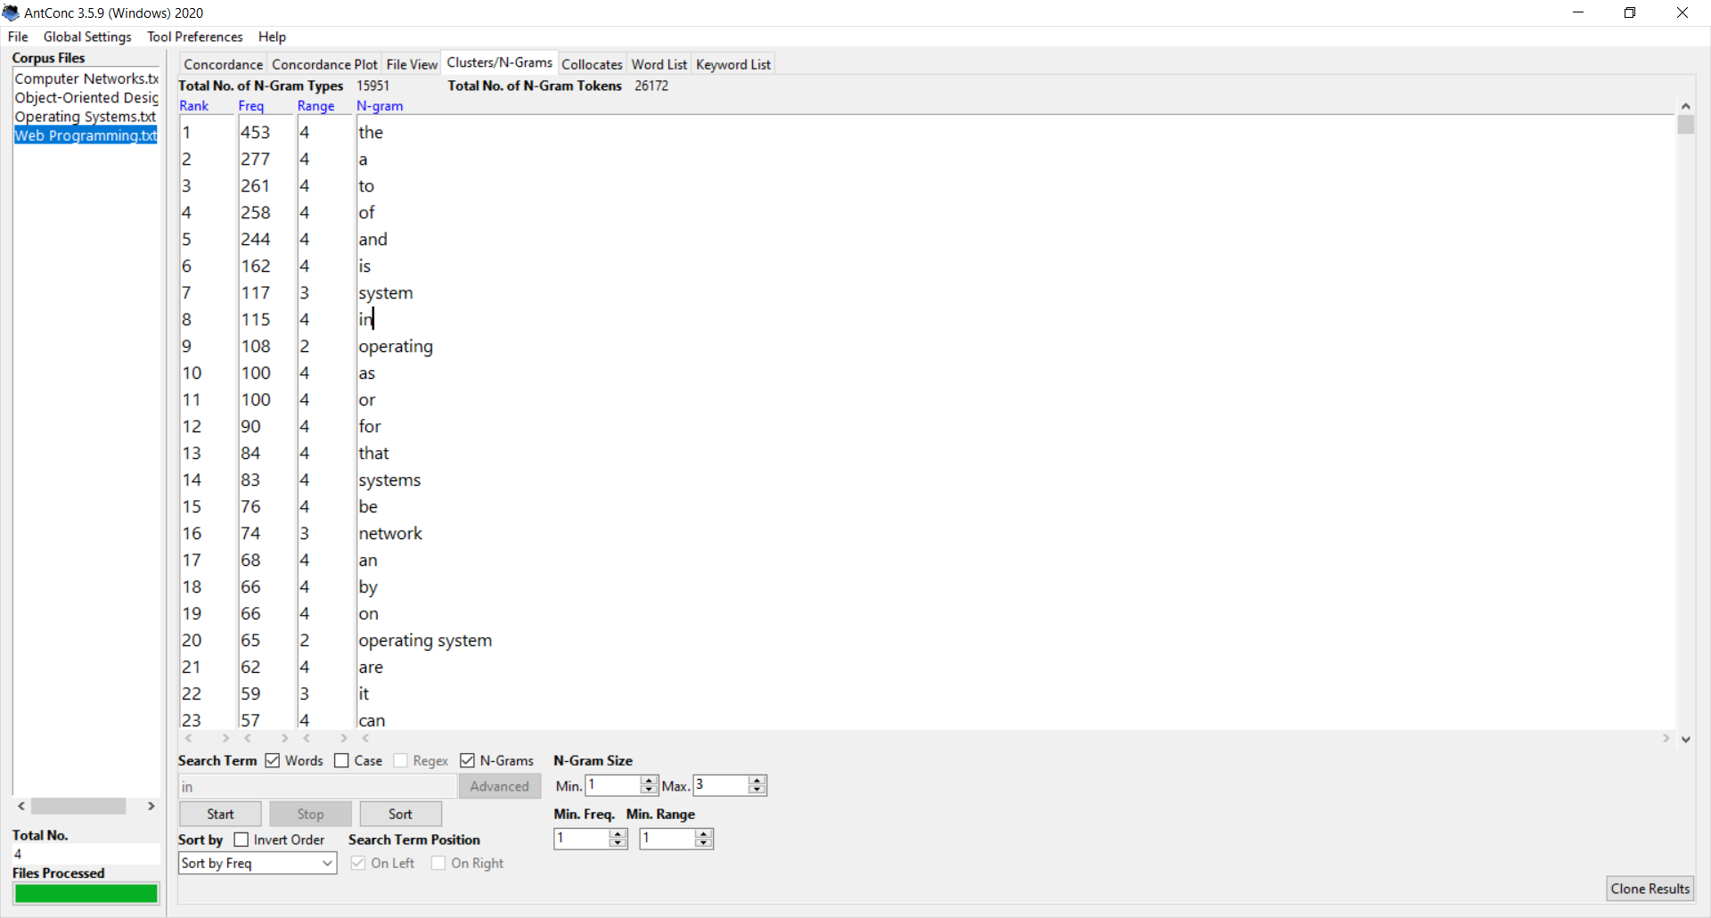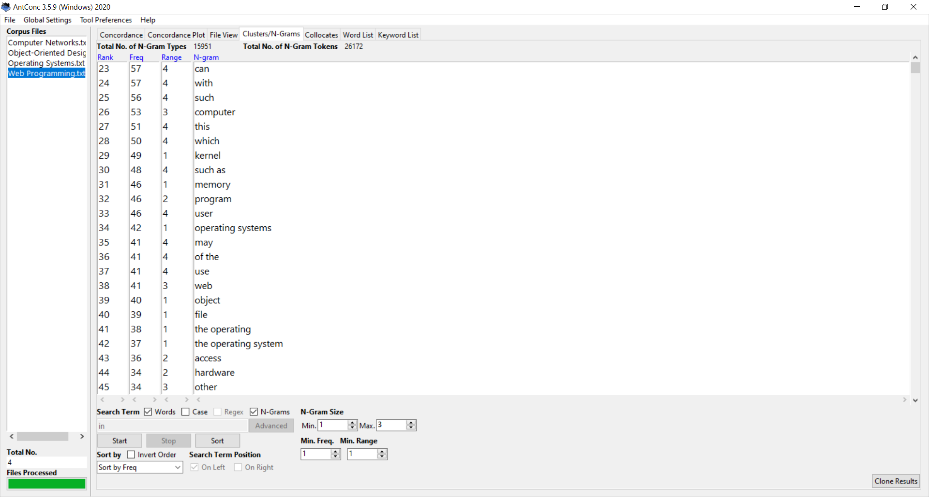

**Most common words:**

1. System
2. Operating
3. Network
4. Computer
5. Kernel
6. Memory
7. Program
8. User
9. Web
10. Object
11. File
12. Hardware
13. Data
14. Device
15. Interface
16. Software
17. Application
18. Development
19. Object oriented
20. Service

***Terms i chose to define:***

**Operating system** – An operating system represents an interface (that connects) between computer’s hardware and it’s end user.

In its core, the operating system, or OS for short, is a piece of software that does “under the hood” tasks which are required for the main program that the computer’s end user is running. Those tasks include: file system, memory, and process managment, handling of user input and output, as well as control of peripheral devices such as printers, hard drives, et cetera.

In order to represent the very use of an operating system, I want you to ask yourselves, how are you reading this? The short answer is, by the help of an operating system.

**Computer network** – A computer network is a group of connected computers that use a set of common communication protocols, over their digital interconnections, for the purpose of sharing resources located on, or provided by, the network nodes.

The innerconnections between network nodes are formed from a broad spectrum of telecommunication network technologies, based on physically wired, optical and wireless radio-friqueny methods that may be arranged in a variety of network toplogies. At the end of these innerconnections you may find: a personal computer (PC), server, networking hardware, or other specialised or general-purpose host which are all united by their general term network node.

A soul purpose of a computer network is to share resources between its hosts. A world-wide computer network, i.e. a network that connects millions of computing devices throughout the world is famous by the name Internet. It trully is one of the greatest inventions of all time and it provides many services, most of which, you are using right now.

**Web (World Wide Web)** – World Wide Web is an information system that allows documents and other web resources to be accessed over the Internet.

**Object (in object oriented programming)** – Object, in computer science, represents an instance of a class that can deploy methodes assigned to it, as well as change its attributes. These objects exist in a program and their interactions describe the behaviour of the code written in object oriented paradigm.

**P.S.**

Since the terms *operating system* and *computer network* are also two of the courses I am taking this semester, I took the liberty of describing them a bit further.

Aleksić Stefan, 16995